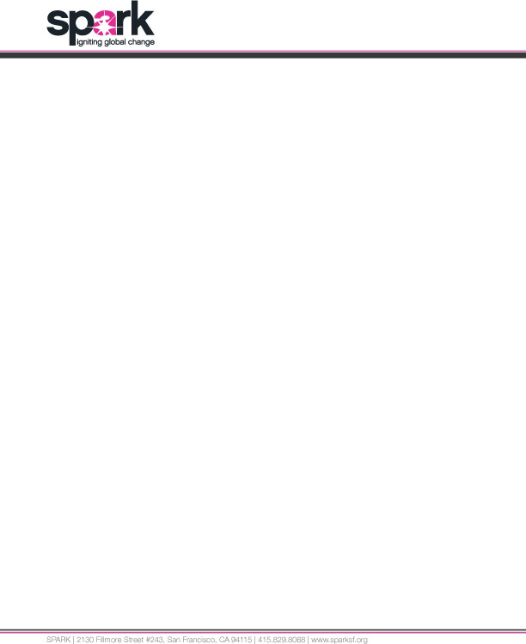

ABOUT US

Spark is a small grant-making organization with operations in San Francisco and New York City. We typically extend grants ranging from $1,000 to $5,000 USD. We only make investments in organizations based in the New York Metro Area, the San Francisco Bay Area or outside of the US.

OUR VALUES

- We believe that investing in innovative grassroots, women-led organizations can transform communities.
- We believe that investing a combination of money, time, connections and attention can have catalytic results.
- We believe that the aggregation of small gifts can have an impact on intractable problems.
- We believe those addressing women’s equity and human rights should be diverse.

CRITERIA

The applicant should match the following profile:
- Founded & Run by Local Women
- Women’s Equality and Human Rights Commitment
- Lack Access to Funds From Other (and Larger) Donor Agencies
- Underserved Geographic Location

The proposed work should have the following characteristics:
- Innovation
- Norm Shifting
- Addresses Root Causes

GRANT APPLICATION

- Date of Request:

- How did you learn about Spark’s Grantmaking Program?

- Is this your first time applying for a grant from Spark?

Yes No

4) Grant Request Amount:

ORGANIZATION INFORMATION

- Name of Organization:

- Mailing Address:

- Physical Address (if different from above):

- Country:

- Organization Website:

- Year Organization Established?:

- Was your organization founded primarily by women?

Yes No

- Is your organization currently primarily managed by women?

Yes No

- Is this organization a registered not-for-profit? (YES/NO CHECK BOX)

Yes No

- If no, please explain (200 Word Limit):

- Please describe the founding and current management format of your organization (500 Word Limit)

- Contact person for this grant:
Name:
Title:
Email:
Telephone:
Fax:

- Name and contact information for two references:

- Describe your organization’s mission and major programs (500 Word Limit):

- What challenge or opportunity does your organization address? (200 Word Limit):

- How many individuals are served by your organization? (100 Word Limit):

- Give an example or tell a story about a way in which your organization has changed or could change the life of a woman? (500 Word Limit):

- What goal would you seek to achieve using a small grant ($5,000 USD or less) from Spark? Please include anticipated timing. (200 Word Limit):

- How will you determine if the project or program is successful? (200 Word Limit):

ADDITIONAL INFORMATION

- Annual operating budget:

- Number of total staff – paid and volunteer:

- Please list your organization’s top funders (names and amounts):

- Please provide the following information on your bank account or your fiscal sponsor’s bank account:
Account name:
Account number:
Sort Code:
SWIFT:
Bank name:
Bank address:
Please attach the following:
  - Project budget
  - Most recent charitable registration document, if applicable

